By:

Ali Hussain

Huma Tariq

Jiyad Khan

Abdullah Shakeel

Adeen Zainub

## “Destructive Leadership Styles”



**Group Assignment**

**Destructive Leadership Styles**

**Subject: Psychology**

***Ali Hussain (19I-1701_N)***

**Huma Tariq (19I-1909_N)**

**Jiyad Khan (19I-1771_N)**

**Abdullah Shakeel (19I-1717_N)**

**Adeen Zainub (19I-1868_N)**

**Project Detail:**

## Topic: “Destructive Leadership Styles”

**Submission:**

**Submitted to:** Ms. Farah Naz

**Due date:** December07’2020.

**Campus:**

NUCES FAST (Islamabad).

**Contents**

* **Introduction**
* **Leadership**
* **Destructive Leadership**
* **Styles of Leadership**
* **Tyrannical style**
* **Derailed Style**
* **Supportive-Disloyal Style**
* **Tyrannical style**
* **Derailed Style**
* **Supportive-Disloyal Style**
* **Conclusion**
* **References**

**Destructive Leadership Style**

**Introduction [1]**

**Leadership:** Leadership issupposed to be an interpersonal supremacy or guidance, which administer towards the acquisition of goals whereas a leader is the person who influence guide and command the people. Moreover, the **Destructive Leadership** is the flaws in interpersonal influence, which administer towards the acquisition of goals. There are three most talked **styles of destructive leadership** that are tyrannical, Derailed and Supportive-Disloyal Style. In ***Tyrannical Destructive Leadership style*** the leader, exercise his powers in a cruel or oppressive way, such type of leaders might be abusive or harassing towards the people they leading. In ***Derailed*** ***Destructive Leadership style,*** the leader considers having a bright future but fail to achieve the required goal according to expectations. Whereas ***in Supportive-Disloyal Destructive leadership style*** the leaders for a time show worries for the prosperity of their supporters and organization but they always priorities their personal benefits over the benefits of the organization they working, and when their personal benefits demolish they might left the organization.

**Tyrannical leadership:**

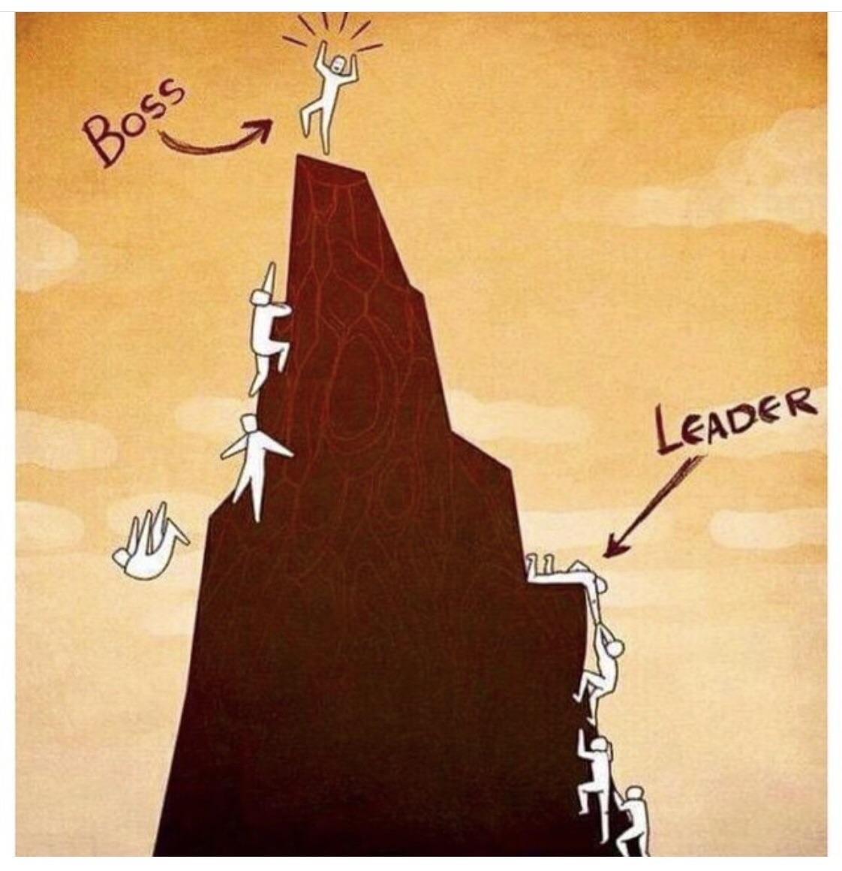The rulers who do things for their own advantage and welfare. The rulers who do not follow law and have cruel behavior for the people of their nation or subject. A tyrant has characteristics like; he does not seek first to understand but to be understand, he blames first and accountable second and he do not practice what he preaches[2]. (Cole, 2016) A tyrant can be leader for an unpracticed person because a tyrant ruler talks about the welfare of the people in the dark times and gives them hope that there will be better days for the ones who are with him. Afterwards he does nothing for them but for himself. For example: if a country’s ruler is a tyrant, he will only think of his own well-being rather than the people of his country. He will do things that will only advantage him like corruption etc. There will be injustice, oppression and poverty in his times. As we often see in offices, when a person reaches a high-level post he starts to abuse the power and his position and always discourage the people lower to him in position and deals with cruelty but can we even call him a leader. The question arises here; can a tyrant called a leader? A tyrant cannot be a leader because a leader only thinks about the welfare and well-being of his nation and the people but a tyrant always thinks about his own advantages. There are some differences such as:

1. Tyrants build walls; leaders build bridges.
2. Tyrants divide people; leaders unite people.
3. Tyrants use negative language to intimidate their followers; leaders use positive language to inspire them. (Sarma, 2017)

**Derailed Styles:**

**Derailed Leadership Styles:**

Derailed Leader are those who consider to have a bright career in the future but are unsuccessful to achieve their achievement or reach up to their expected stage of the success. This Derailed Leader shows two type of behavior to the society at the time. These behaviors are **anti-subordinate behaviors** like bulling, harassment or manipulate or **anti-organizational behaviors** like fraud or theft. Jay A. Conger (1990) specified or defined the “derailed leadership as the dark side of the leadership” because of derailed leader’s behavior. Jay A. Conger (1990) suggest a three different kind of solution which may provide and support to the Derailed Leader to overcome their problems which are strategic idea or view, connection or communicating and good capacity to manage. Jay A. Conger suggest this solution so that they can overcome their problem. Because these derailed leader are unsuccessful to handle their problems, hostilities and confrontation. Instead, they spread more and different ways to boost up more problems and confrontation [3]

Jay A. Conger (1990) also realize that derailed leader may use their power or qualities just for their own purpose or their own personal gain and turn up against their own people which has supported him. There is a best example of the derailed leadership, which is “Pervez Musharraf who is the former president of the Pakistan”. Controlling the power is one of his ambition. By this power, he wanted to achieve every ambition and objective. Due to this, he make some decision just to stretch or increase their rule and protect their position. This decision is not giving the benefit to the country but to his personal agenda. In the end of the day, he was unsuccessful of the result that he wanted. Instead of learning the mistake, he repeatedly repeating the same mistake when a point is came where he also lost their position.

**Supportive disloyal leadership style:**

Destructive leadership style occurs in an organization when leader become disloyal or supportive. Supportive leadership style is simply organic and emotional style like other leadership styles and sometime useful and affective in some situation in an organization. When we talk about the supportive disloyal leadership style, it shows the consideration and motivation to followers but at same time, it violates the goal of organization and misuse or stealing the organization resources like material and time. Supportive disloyal leader provides more to their followers then organization and gain trust from their followers. They show their followers that they valued their followers and give honor to them but the in the foreground their aim is to gain followers trust. Simultaneously, they undermine the goal of organization. Supportive disloyal leadership can create this type of style in follower through the example they have set. They think that they are doing well for their follower by violating the legitimate interest of organization.

Sometime it is hard to find destructive leader in an organization because of positive benefit and support from their followers. To avoid from destructive leadership simply create an environment of working which encourage honesty and loyalty. Then simply explain the goals of organization to its followers or employees. Simply give respect to followers and get respect from them and be truthful even it hurts and show care toward followers. One of the most important things that leader should connect with followers on personal level which show respect and care to followers and must give reward to employees. In order to get loyalty from its followers or employees the organization should first give it to them.

**Conclusion:**

A leader is a person that not only leads but also shows the way to people. He is someone who not only do work for others but also shows others the way to do the work himself or herself. A leader needs to be honest to his work and people and if he is not honest, it leads to the destruction of his entire surrounding. A destructive leader trails his way to achieve his destructive and self-benefiting goals and through this way his allegiance and fidelity towards his organization and work changes his leadership into a destructive leadership. So choose you your leader wisely and if you become a leader, be the like the one, you wanted to have.

**References:**

1. Aasland, M. S., 2007. *Destructive leadership behavior: A definition and conceptual model.* [Online]   
   Available at: https://www.researchgate.net/publication/222819132_Destructive_leadership_behavior_A_definition_and_conceptual_model#:~:text=Three%20categories%20of%20such%20destructive,behaviour%2C%20and%20aggression%20at%20work.  
   [Accessed 1 12 2020].
2. Cole, N., 2019. *3 Personality Traits That Reveal Whether You're a Leader or a TyrantKnow the difference..* [Online]   
   Available at: https://www.inc.com/nicolas-cole/3-personality-traits-that-reveal-whether-youre-a-leader-or-a-tyrant.html  
   [Accessed 3 12 2020].
3. All Answers Ltd. November 2018. Literature Review of Dysfunctional Leadership. [online]. Available from: https://ukdiss.com/litreview/a-literature-review-of-a-relevant-leadership-trend.php?vref=1 [Accessed 6 December 2020].